PUNE INSTITUTE OF COMPUTER TECHNOLOGY

(DHANKAWADI, PUNE-43)



MINI PROJECT REPORT ON

“DIGITAL RECORD BOOK”

SUBMITTED BY

Shubham Joshi(3025)

Sameer Kulkarni(3031)

Arshad Khan (3029)

Aditya Kakliya (3026)

(Third Year Information Technology)

UNDER THE GUIDANCE OF

Prof J. K . Kamble

Prof S.A. Jakhete

Submitted To

**Pune Institute of Computer Technology**

**For Academic Year 2017-18**

# Abstract

Assignment Submissions are undoubtedly the most hectic tasks in college life. Checking long journals and entering its records in the hard cover record book can be very cumbersome to a professor. The sole of the project is to make this task as efficient as possible with zero paper-work for record keeping. The project provides a platform to keep record for the user ( majorly comprising of Professors and Students ) and easy retrieval of the required information to the user. Currently the project has been structured purposefully to meet the need for users of Pune Institute of Computer Technology.

Keywords : Assignment Submissions, hectic, cumbersome, zero paper-work, Professors, Students, record keeping

DIGITAL RECORD BOOK

# Acknowledgements:

The team is very thankful to Prof. J. K . Kamble and Prof. S. A . Jakhete for their valuable feedbacks in making this project successful and helping throughout the process in technical issues and working solutions to them.

The team would like to express special thanks of gratitude to all the Staff members of PICT TE IT Dept.

THANKS AGAIN TO ALL WHO HELPED US.

|  |  |  |  |
| --- | --- | --- | --- |
| Topic No | Sub Topic No | Title | Page No |
| 1 |  | Introduction | 5 |
|  | 1 | Purpose , | 5 |
|  | 2 | Scope | 5 |
|  | 3 | Definition,Acronym, and Abbreviations | 5 |
|  | 4 | References | 6 |
|  | 5 | Developers’ Responsibilities: An Overview | 6 |
| 2 |  | General Description | 7 |
|  | 1 | Product Function Perspective | 7 |
|  | 2 | User Characteristics. | 8 |
|  | 3 | General Constraints | 8 |
|  | 4 | Assumptions and Dependencies | 9 |
| 3 |  | Specific Requirements | 10 |
|  | 1 | Inputs and Outputs | 10 |
|  | 2 | Functional Requirements | 10 |
|  | 3 | Functional Interface Requirements | 10 |
|  | 4 | Performance Constraints | 10 |
|  | 5 | Design Constraints | 10 |
|  | 6 | Acceptance criteria |  |
| 4 |  | Limitations | 11 |
| 5 |  | System Design | 12 |
|  | 1 | ER Model | 12 |
|  | 2 | Schema Description | 13 |
|  | 3 | Tables Descriptions | 14 |
|  | 4 | System Flow chart / Activity diagram | 21 |
|  | 5 | User Interface Design | 22 |
|  | 6 | Error Messages / Alerts Design | 27 |
|  | 7 | Test Case Design | 29 |
| 6 |  | System Implementation | 30 |
|  | 1 | Hardware and Software Platform description | 30 |
|  | 2 | Tools used | 30 |
|  | 3 | System Verification and Testing (Test Case Execution) | 30 |
|  | 4 | Future work / Extension | 30 |
|  | 5 | Conclusion | 31 |

# 1. Introduction:

Submissions are arguably the most hectic period in college life. Checking long journals and entering its records in the practical record book can be very boring and cumbersome to a professor .We have made an honest effort to minimize this labor work and rather work in a smart digital way by creating an online assignment submission forum for approving students assignments and also grading him and approving his work . So presenting before you DIGITAL RECORD BOOK.

1.1 Purpose:

* To digitize the system for record keeping of assignments.
* To help the Professors and the Students to retrieve their complete records for a particular semester with one click only.
* To introduce a system in the academic departments of the college to abolish paper-work for record keeping of Students Assignment Submission

1.2 Scope:

* The Digital Record book can be used in all engineering institutions with little to no configuration.
* This web Application is made for maintaining assignment records for students for a particular department.
* Centralized Administrator has the control on all activities like adding a faculty to database ,allotment of particular faculty for a subject and dividing students in groups ,assigning Subject coordinator,etc.
* Each teacher can assess the students from his/her batch and also upload assignment /Question Bank to students which can be in turn downloaded by the students in PDF format.
* A teacher can search for a particular student record by his Roll Number and assess him separately.
* The facility for calculation of TermWork is also provided in the Web Application.

# 1.3 Definition, Acronym, and Abbreviations

Assignment : a task or piece of work allocated to someone as part of a job or course of study.

SC : Subject Coordinator

PDF : Portable Document Format

# 1.4 References

“MySQL” by Paul DuBois

**Oracle® Database** JDBC Developer’s Guide and Reference

<https://www.w3schools.com/>

<https://stackoverflow.com/>

# 1.5 Developers’ Responsibilities: An Overview

The Developer is responsible for maintaining up-to-date plugins and the drivers used in the project and also to deploy the system in the approaching instituetion or college. The deployment of the project requires the following steps which the developer is responsible for :

1. Integrate the complete MYSQL database and the source files of the project on the main server of the college or instituetion.

2. Configure the MYSQL database at the server system

3. Create all the selected systems as a client which will send requests to the above mentioned server for any updation or retrieval of the information.

4. Set up an administrator and provide credentials for the admin login to render all the necessary information about the framework of the semester for the future use of the application by the users.

# 2. General Description

2.1 Product Function Perspective

The Physical inputs to the server system are as follows :

1. Information about Classes/Batches/Groups

2. Information about Teachers/Professors

The Physical outputs to the any client system are as follows :

Teacher/Professor as a user :

1. Get records of an existing assignment

2. Creation of an assignment

3. Updating complete record of a student for the selected assignment

4. Get all the submitted records for a particular student and update the same.

5. Get complete report of the selected batch/class/group

6. Generation of the submission ticked of the selected batch/class/group

7. Updation of unit test marks of any student in the selected batch/class/group

8. Upload any document in the pdf format onto the server for the retrieval by any student as a user.

Student as a User :

1. Subjects for which the submission ticket is approved by corresponding subject teacher

2. Complete record for all the assignments of a particular subject.

3. Performance in all the unit tests of all the subjects

2.2 User Characteristics

The complete project is divided among three types of users :

1. Administrator

2. Teacher/Professor

3. Student

Administrator :

A responsible person need to render specific information about the framework of complete semester/term to the system. Administrator of the project will provide all such information to the system.

Teacher/Professor :

Basically, any Teacher/Professor wants to update or retrieve all the relevant information about a student to/from the system. The teacher/professor as a user will be able to do the same.

Student :

A Student wants to see his complete record and performance for any subject of that semester/term and to check if he has got an approval for the submission ticket of a particular subject or not .

The Student as a user will be able to do the same.

2.3 General Constraints

1. The Administrator must add a Teacher/Professor entry beforehand or otherwise, the Teacher/Professor would not be able to login.

2. An Internet Connection to every client user is a must condition to use the system in the desired manner.

2.4 Assumptions and Dependencies

1. For Teacher as a user, their UserID is auto generated and is given by the Administrator and their by default password is ‘abc’. The Teacher has facilited to change their password as per their convenience.

2. We have assumed that the UserID which is auto-generated is unique for all the Teachers. We have calculated all the possibilities and we found that it is rarest of the rare case that two Teachers will be allotted a same UserID.

In that case, the systems comes is a fault for one of the two Teachers.

3. For Student as a user, student needs to create his own login by clicking on ‘Sign Up’ button on the landing page of the application.

# **3. Specific Requirements:**

3.1 Inputs and Outputs

For inputs, all the inputs should be given in English ( United States ) language and UTF-8 charset supporting keyboard.

For the correct display of the output with prospective formatting, the browser must be updated to its latest version as the project uses HTML5,CSS,JQUERY,JS,BOOTSTRAP as frontend technologies.

3.2 Functional Requirements

For the application to be used, the system must have a working connected internet connection.

3.3 Functional Interface Requirements

All the input fields in the application has been validated on the client side for the appropriate input. User will get a pop -up notification if he gives an invalid input.

3.4 Performance Constraints

Performance of the system depends upon the total number of uploaded documents on the server. It shows an inverse proportionality. Although, for a decent number of stored documents on the server, every query runs within 2 seconds.

3.5 Design Constraints

The browser must support HTML5 and it needs to be updated to its latest version.

3.6 Acceptance criteria

All the information provided by the Administrator must be 100% genuine.

# LIMITATIONS

1. Application does not have facility for hosting online tests.
2. Students cannot upload their Assignment journals online, they need to be hand-written.

The main modules in this Project are as follow

* Administrator
* Teacher
* Student
* Assessment of Assignment
* Calculation of Term Work
* Generation of Submission Ticket
* Records of Unit Test Marks

# 5. System Design:

5.1 E R Diagram

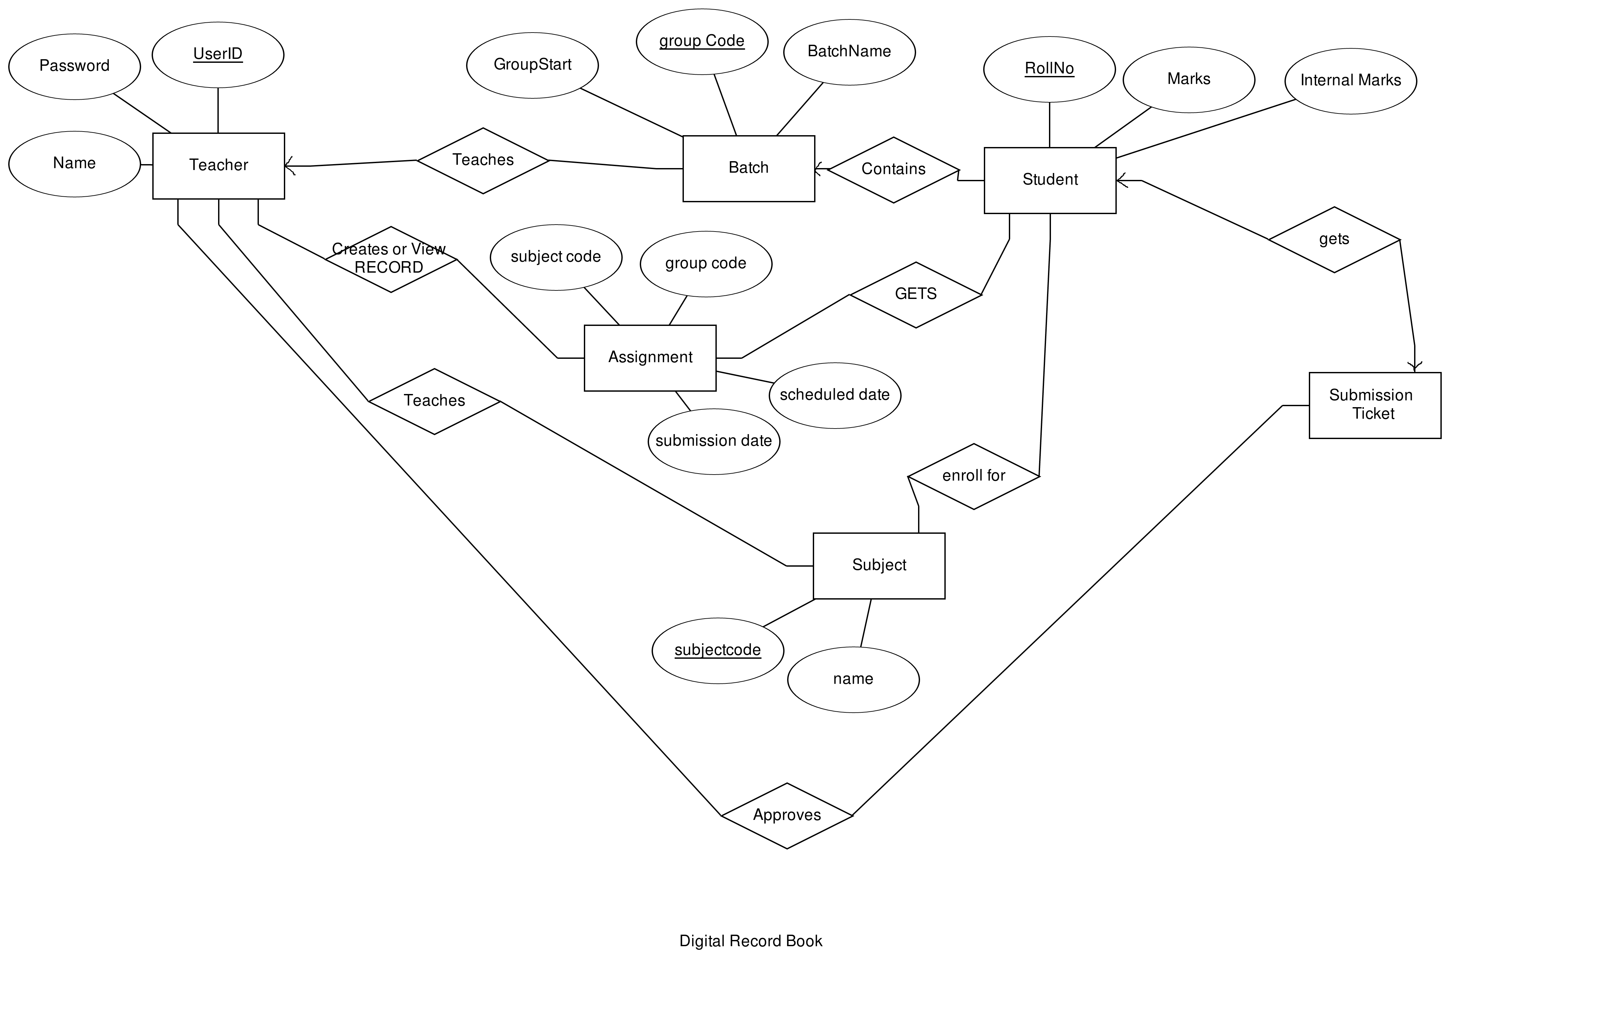

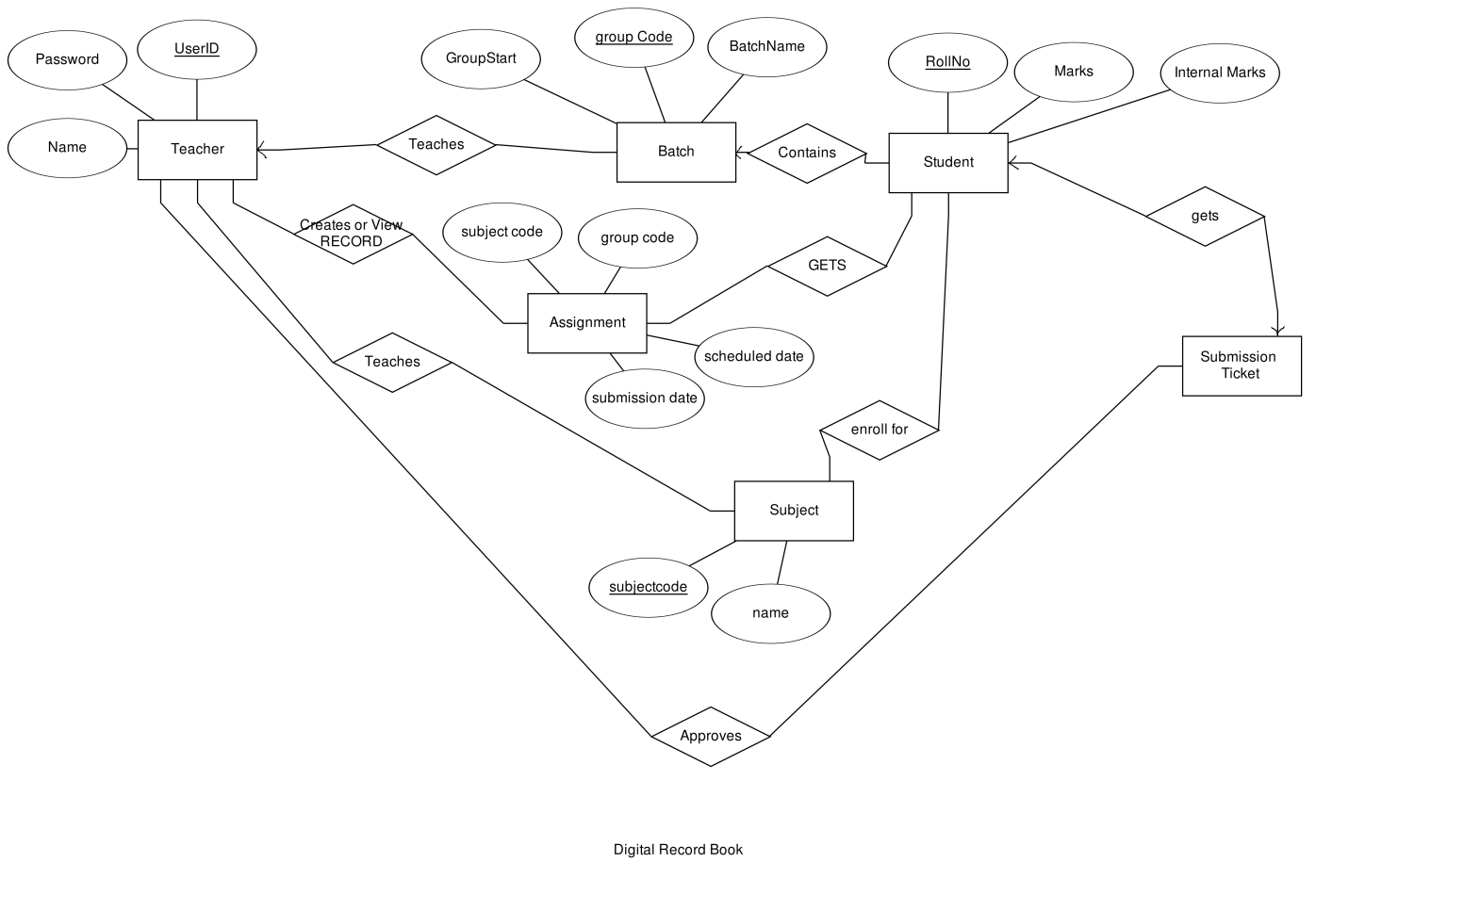

5.2 Schema Description:

Table List

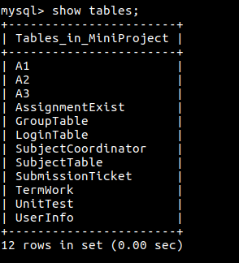

Fig a

5.3 Tables Description

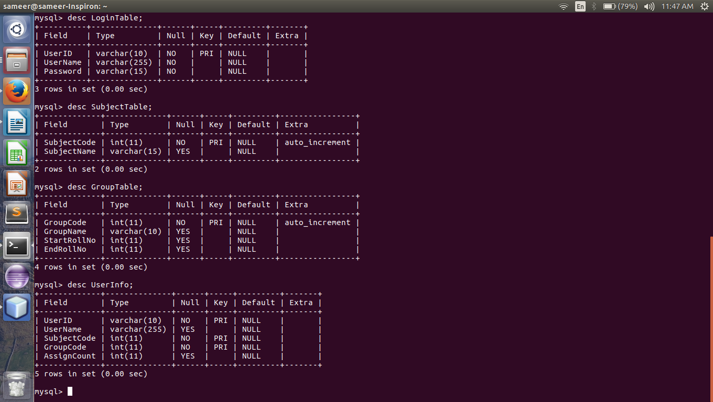

Fig b

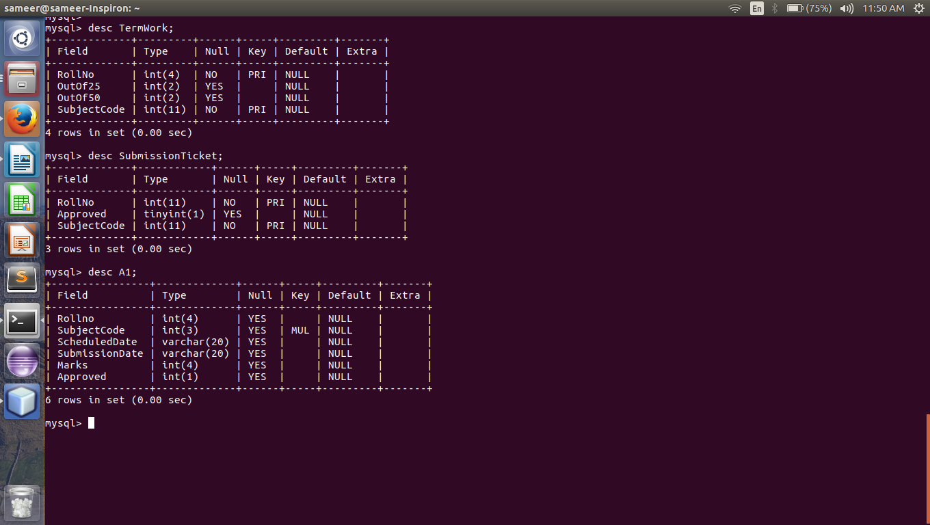

Fig c

5.5 Procedure Descriptions

1.Procedure for creating a table named Assignment_n ( where n varies from 1 to infinity)

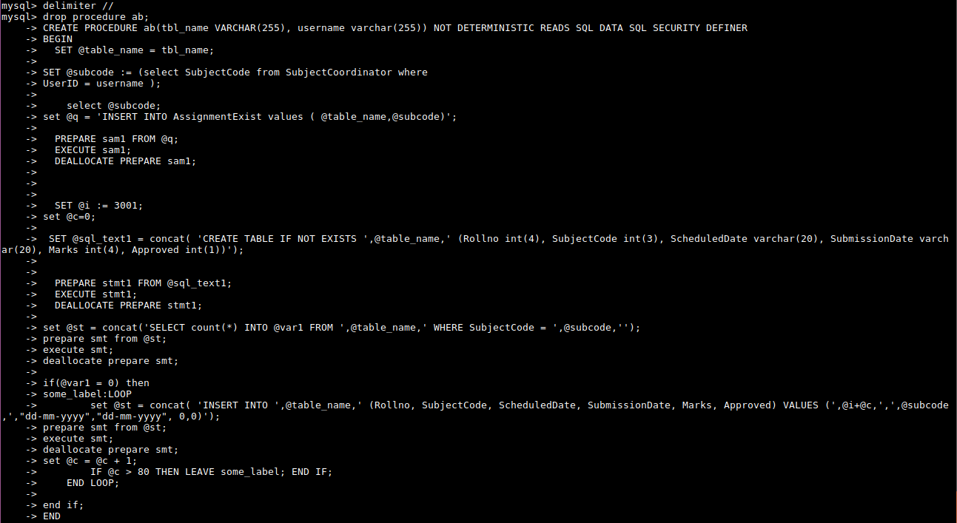\ Fig d

2.Procedure for truncating all tables

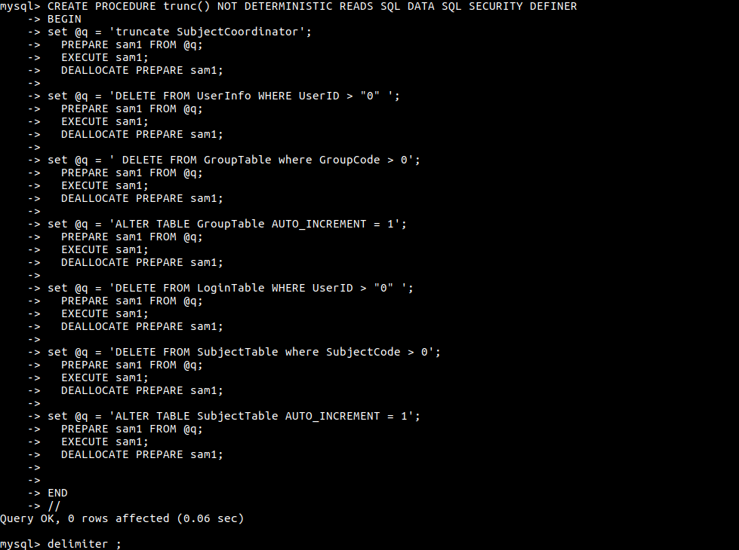 Fig e

3. Procedure to Create a Unit Test

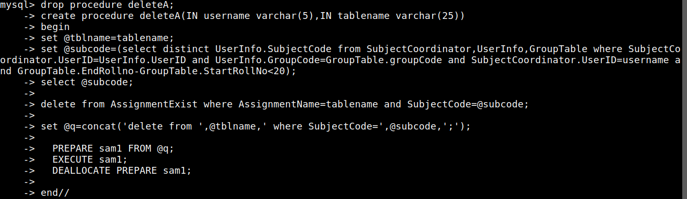 Fig f

4. Procedure to Delete an Assignment

 Fig g

Triggers Description

Trigger to delete corresponding User entries if a user is deleted

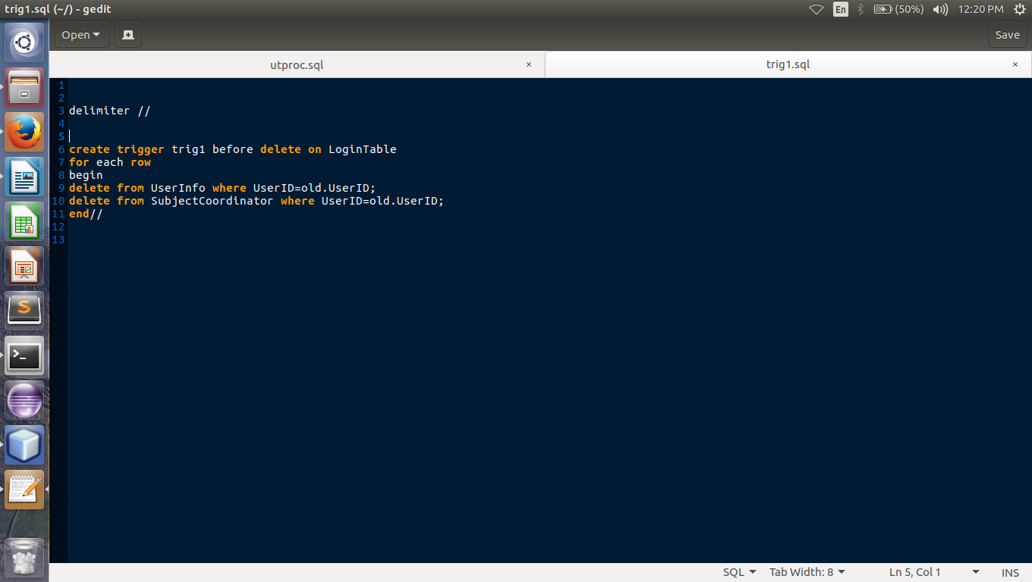

Fig h

Trigger to delete corresponding subject entries if a Subject is deleted

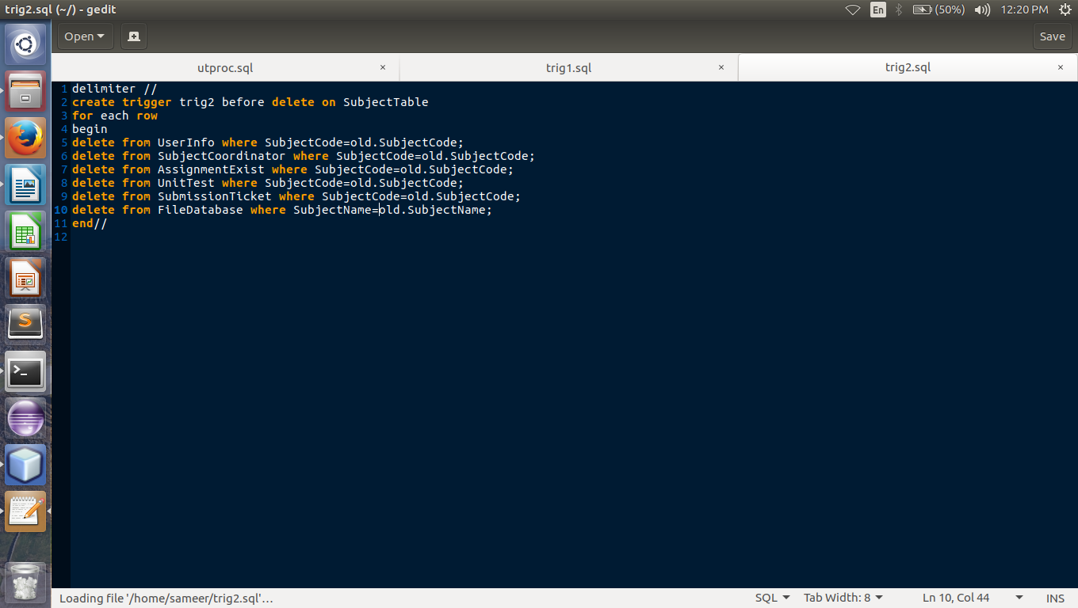

Fig i

Trigger to delete assignment entries if Subject is deleted

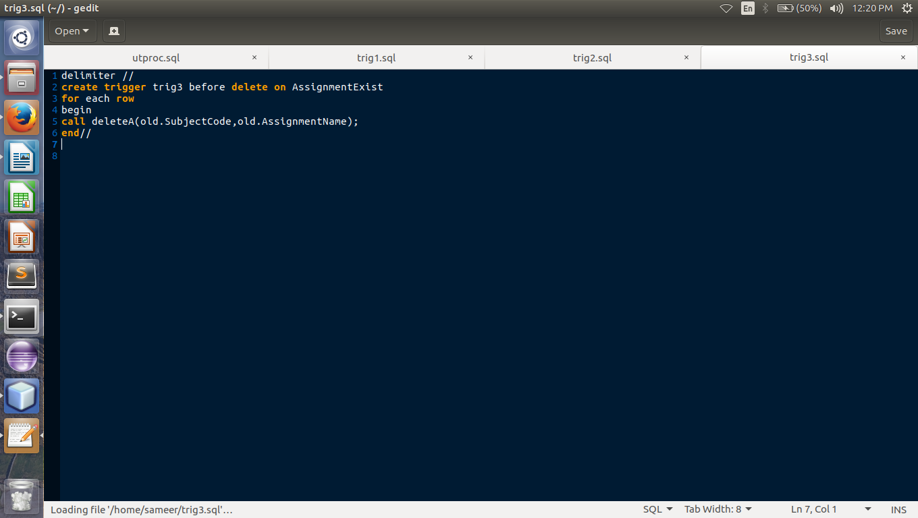

Fig j

Trigger to delete corresponding entries if one group is deleted

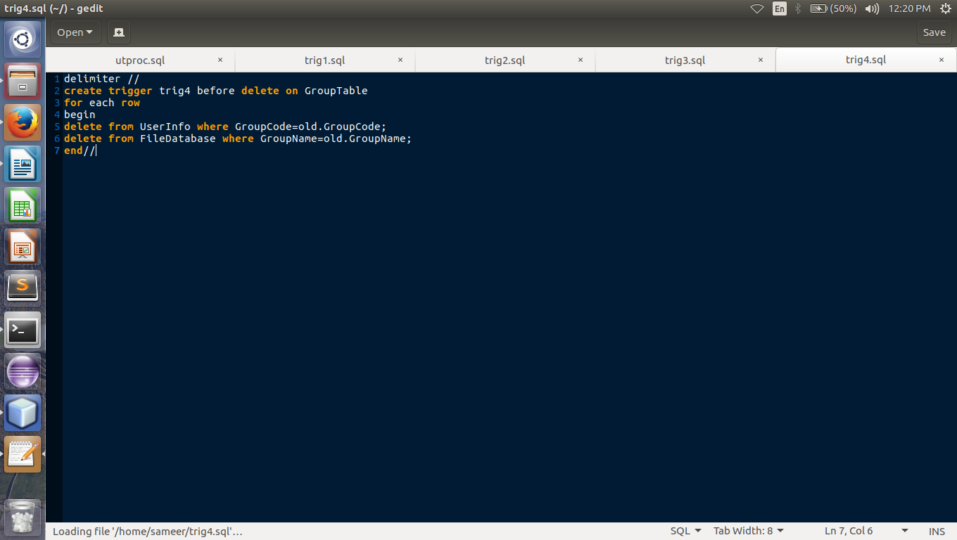

Fig k

# 5.4 System Flow chart / Activity diagram

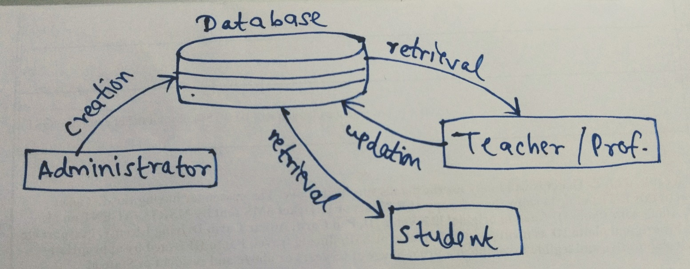

Fig l

# 5.5 User Interface Snapshots (along with Test Case Design)

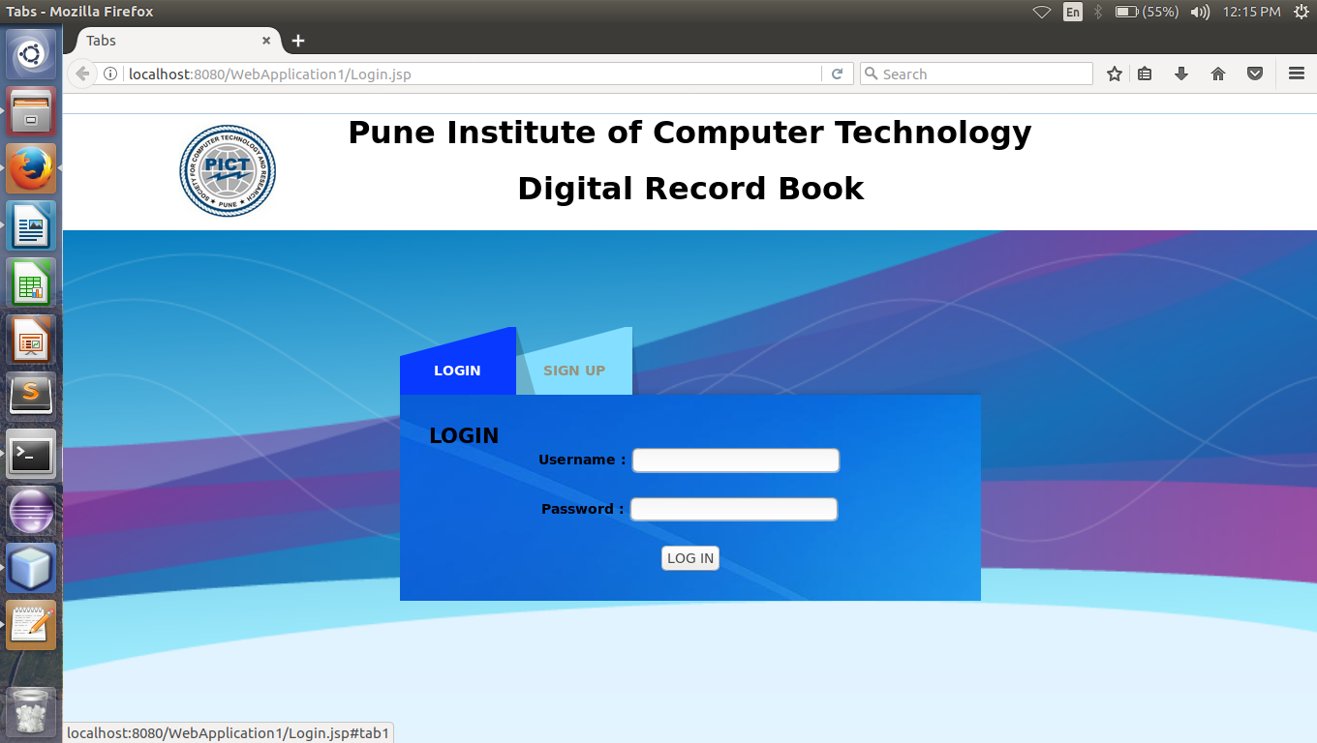 Fig 1

# Fig 2

# Fig 3

# 

Fig 4

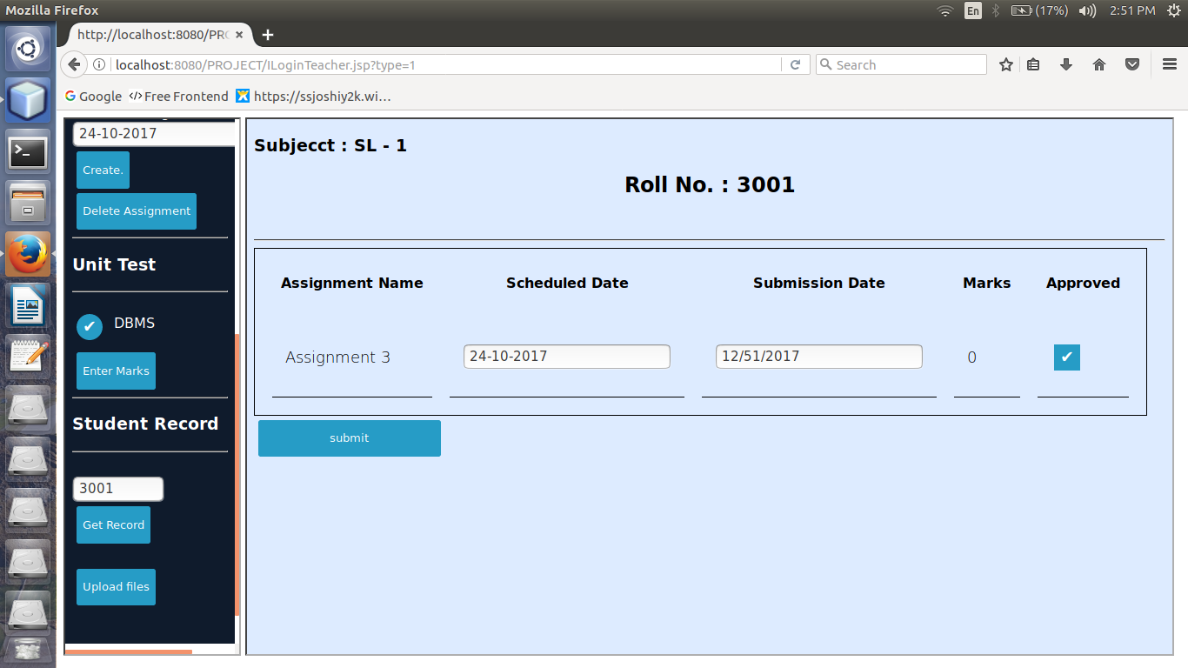 Fig 5

# Fig 6

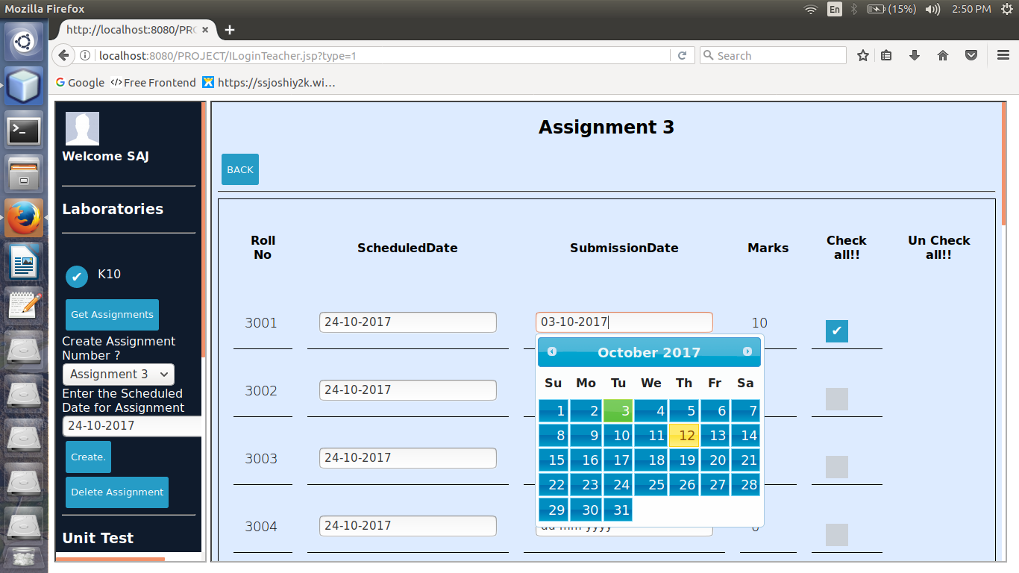 Fig 7

# Fig 8

# Fig 9

# 

5.6Error Messages / Alerts Design

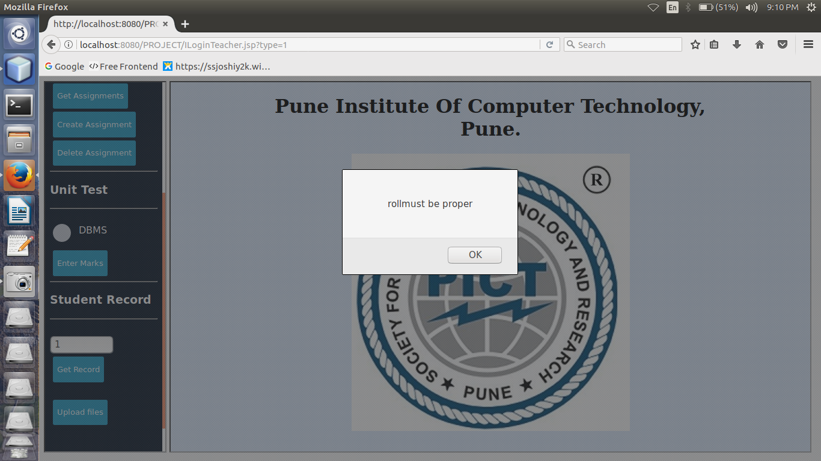

Fig 10

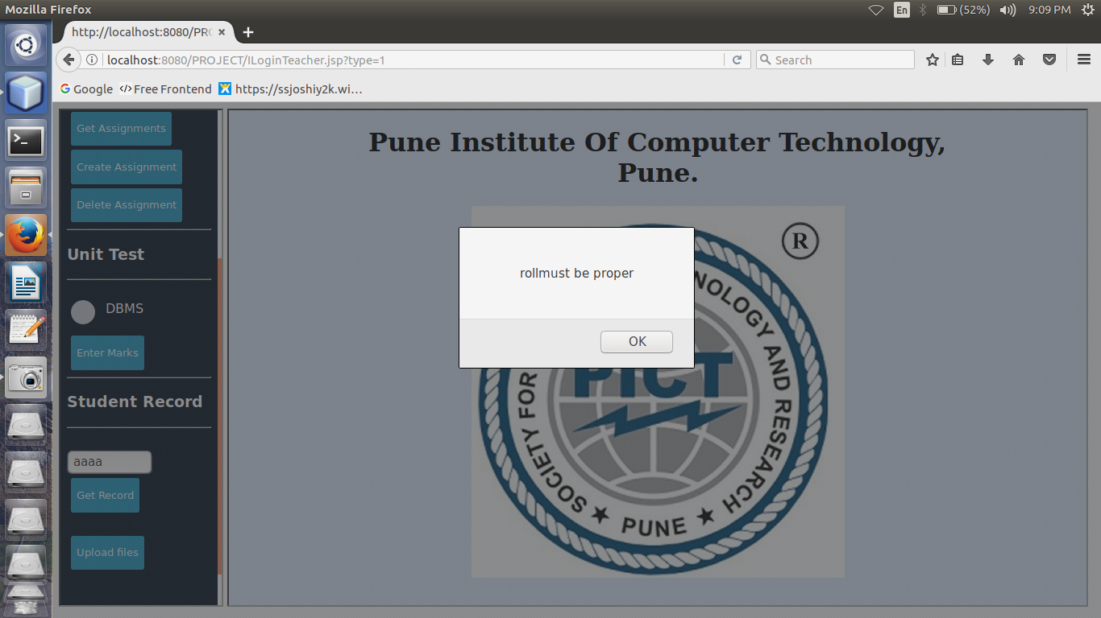

Fig 11

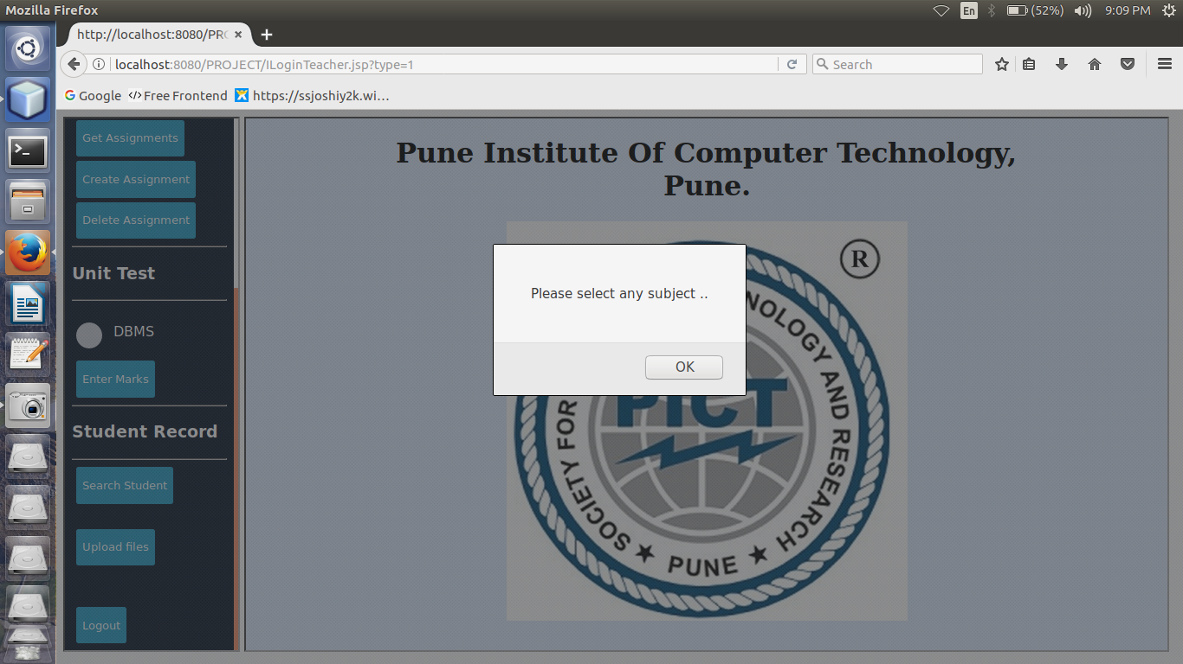 Fig 12

5.7Test Case Design

 Fig 13

**6. System Implementation**

6.1 Hardware and Software Platform description

The Hardware platform needed to run the application must be of minimum 128MB RAM and must have a wireless card for connecting to a wifi or Ethernet port.

The Software platform for system as a server must have mysql installed and for clients, a browser is needed to run the application.

# 6.2 Tools used

The Digital Record Book is successfully implemented using the following technologies :

BackEnd :

MySQL relational database

Connectivity :

JAVA JDBC Driver

FrontEnd :

HTML5, CSS, W3 RESOURCES, BOOTSTRAP, JAVASCRIPT, JQUERY.

6.3 System Verification and Testing (Test Case Execution)

Refer to Section 4.5

6.4 Future work / Extension

The future scope of the project is to implement the same in PICT college and making sure that the system is homogeneously dissolved throughout a complete semester/term.

Long term goals of the project is to help different educational institutes to use the developed system for their colleges/institutions and create it as a non-profit based open source web application.

6.5 Conclusion

The project has been an immense success and its flexibility is unquestionable. By using the Admin panel, one can easily create a database for an appropriate Submission management System. It can be used in any educational institutes with great ease. Updation and display of all the tables are in real-time and the frontend module that has been integrated uses open cdn networks for various technologies. The duration to complete this project took 45 days of sincere efforts with each working day comprising of around 6 working hours.

**References**

**“MySQL” by Paul DuBois**

**Oracle® Database** JDBC Developer’s Guide and Reference

<https://www.w3schools.com/>

<https://stackoverflow.com/>

**Annexure:**

1. GUIs / Screen Snapshot of the System Developed
2. Part –A: SQL and PL/SQL, Triggers, Stored Procedures, Functions